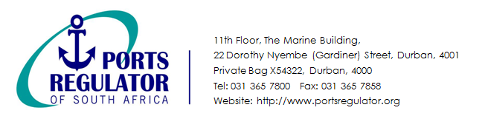

11th Floor, the Marine Building,

22 Dorothy Nyembe Street, Durban, 4001

Private Bag X54322, Durban, 4000

Tel: 031 365 7800

Website: http://www.portsregulator.org

**The National Ports Authority Tariff Application 2017 / 2018**

**Registration Form**

|  |  |  |  |  |  |  |  |
| --- | --- | --- | --- | --- | --- | --- | --- |
| **Name of Company / Organisation:** |  | | | | | | |
| **Roadshow Dates** | DBN | 02/09/2016 | | The Riverside Hotel | | | |
| **Roadshow Time: 09h00 – 13h00** | JHB | 05/09/2016 | | Southern Sun OR Tambo Hotel | | | |
| P.E | 06/09/2016 | | Garden Court Kings Beach Hotel | | | |
| CPT | 07/09/2016 | | The Pepperclub Hotel | | | |
| **No. of Individuals Attending:** |  | | | | | | |
| **Name of Individuals Attending:** | **Email Address:** | | **Roadshow: Please Select** | | | | |
| **DBN** | | **CPT** | **JHB** | **PE** |
|  |  | |  | |  |  |  |
|  |  | |  | |  |  |  |
|  |  | |  | |  |  |  |
|  |  | |  | |  |  |  |
|  |  | |  | |  |  |  |
|  |  | |  | |  |  |  |
|  |  | |  | |  |  |  |
|  |  | |  | |  |  |  |
|  |  | |  | |  |  |  |
| **The completed form may be emailed to** [**eventsregistration@portsregulator.org**](mailto:eventsregistration@portsregulator.org) **to confirm registration.** | | | | | | | |
| **Contact Details:** | | | | | | | |
| **Name:** |  | | | | | | |
| **Contact Number:** |  | | | | | | |
| **Date:** |  | | | | | | |