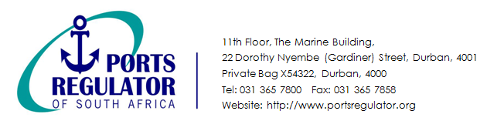

11th Floor, the Marine Building,

22 Dorothy Nyembe Street, Durban, 4001

Private Bag X54322, Durban, 4000

Tel: 031 365 7800

Website: http://www.portsregulator.org

**The Review of the Tariff Methodology**

**Registration Form**

|  |  |  |  |  |  |  |  |
| --- | --- | --- | --- | --- | --- | --- | --- |
| **Name of Company / Organisation:** |  | | | | | | |
| **Roadshow Dates** | JHB | 24/10/2016 | | Emperors Palace Hotel | | | |
| **Roadshow Time: 09h00 – 13h00** | P.E | 25/10/2016 | | Garden Court Kings Beach Hotel | | | |
| CPT | 26/10/2016 | | The Townhouse Hotel | | | |
| DBN | 31/10/2016 | | The Waterfront Hotel | | | |
| **No. of Individuals Attending:** |  | | | | | | |
| **Name of Individuals Attending:** | **Email Address:** | | **Roadshow: Please Select** | | | | |
| **DBN** | | **CPT** | **JHB** | **PE** |
|  |  | |  | |  |  |  |
|  |  | |  | |  |  |  |
|  |  | |  | |  |  |  |
|  |  | |  | |  |  |  |
|  |  | |  | |  |  |  |
|  |  | |  | |  |  |  |
|  |  | |  | |  |  |  |
|  |  | |  | |  |  |  |
|  |  | |  | |  |  |  |
| **The completed form may be emailed to** [**eventsregistration@portsregulator.org**](mailto:eventsregistration@portsregulator.org) **to confirm registration.** | | | | | | | |
| **Contact Details:** | | | | | | | |
| **Name:** |  | | | | | | |
| **Contact Number:** |  | | | | | | |
| **Date:** |  | | | | | | |